

Techwiz5 Documentation on Expense Voyage



|  |  |  |
| --- | --- | --- |
| **FACULTY:** | **Sir. Tehami Faisal** | |
| **BATCH:** | **2307f /2310a** | |
| **EPROJECT:** | **Expense Voyage** | |
| **S. NO.** | **ENROLLMENT NO.** | **STUDENT NAME.** |
| **1.** | * **1481279** | **Zaid Khan** |
| **2.** | * **1477316** | **M.Masoom Mallah** |
| **3.** | * **1527753** | **Kinza Ul Mehak** |

*1.*Acknowledgement*:*

*First, we would like to express my special thanks to my teacher SIR. Tehami Faisal who helped a lot in finalizing this project within the limited time frame, valuable counseling and assistance for the accomplishment of this project.*

*Secondly, we would also like to thanks the techwiz team at Aptech Head Office, who gave as the opportunity to do this interesting and wonderful project about ExpenseVoyage*

*Thirdly, we also thank the Techwiz team for giving this task to us. Following are the benefits of this Project:*

* *Re-enforcement of skills happens in the experimental learning process.*
* *A mentor, ensuring that we do not get drifted, constantly guides us.*
* *It gives us a lot of confidence to face an interview as we have worked on a project. We can explain virtually everything on the subject we have learnt.*
* And finally, we would like to offer thanks to all my colleagues for their valuable suggestions.

**Thank you.**

*2. Synopsis:*

**ExpenseVoyage Laravel Website Synopsis:**

Traveling, whether for business or leisure, often involves managing multiple expenses. These expenses can quickly accumulate, leading to the necessity for meticulous tracking to stay within budget. Many travelers, however, struggle with maintaining an organized record of their expenditures, leading to overspending, loss of receipts, and difficulty in reimbursement claims.

The website is built with a responsive design, ensuring a seamless experience across various devices, including desktops, tablets, and smartphones.

*3.PROJECT ANALYSIS:*

### ***1. Project Overview***

* ***Objective****: Clearly define the purpose of the project. What are you hoping to achieve with the expense voyages?*
* ***Scope****: Outline what is included in the project and what is not. Are you focusing on a specific type of voyage or geographical area?*

### ***2. Data Collection***

* ***Types of Data****: Identify the data you need (e.g., travel costs, duration, destinations, accommodation).*
* ***Sources****: List where you’ll gather data from (e.g., travel agencies, online platforms, personal records).*

### ***3. Cost Analysis***

* ***Direct Costs****: Breakdown of transportation, accommodation, food, and activities.*
* ***Indirect Costs****: Include any hidden costs like insurance, taxes, or fees.*
* ***Budget Comparison****: Compare actual costs against planned budgets to identify discrepancies.*

### ***4. Trends and Patterns***

* ***Travel Frequency****: Analyze how often voyages occur and any seasonal patterns.*
* ***Cost Trends****: Look for trends in expenses over time or by category.*

### ***5. Stakeholder Impact***

* ***Who is Affected?****: Identify stakeholders (e.g., employees, clients, partners) and how they are impacted by the expenses.*
* ***Feedback Mechanisms****: Plan for collecting feedback from stakeholders about their travel experiences and expenses.*

### ***6. Efficiency Assessment***

* ***Cost-Effectiveness****: Evaluate whether the expenses lead to desired outcomes (e.g., increased productivity, business growth).*
* ***Alternative Options****: Consider other methods of achieving the same goals at a lower cost (e.g., virtual meetings).*

### ***7. Recommendations***

* ***Cost Reduction Strategies****: Suggest ways to minimize expenses (e.g., preferred vendors, early bookings).*
* ***Policy Improvements****: Propose changes to travel policies to enhance efficiency and satisfaction.*

### ***8. Conclusion***

* ***Summary of Findings****: Recap the key insights gained from the analysis.*
* ***Next Steps****: Outline any actions that need to be taken based on your analysis.*

### ***9. Appendices***

* ***Supporting Data****: Include any charts, graphs, or additional data that support your analysis.*

*Feel free to expand on any of these sections or let me know if you need more specific information!*

*PROBLEM STATEMENT*

***Introduction***

*PROBLEM STATEMENT*

*Managing travel expenses can be a significant challenge for individuals and organizations. Travelers often struggle to track and categorize their expenses, leading to poor budget management, inaccurate financial reporting, and overspending. Organizations, on the other hand, face difficulties in managing and monitoring travel-related expenses for their employees, often lacking a streamlined system to organize trips, categorize costs, and generate reports.*

*Our project aims to develop a comprehensive travel expense management system using Laravel 11. This system will allow users to plan trips, categorize expenses, and maintain an accurate record of all travel-related costs. With features like destination management, expense tracking, trip categorization, and real-time data analysis, the platform will simplify the process of monitoring travel budgets, making it easier for individuals and organizations to control their travel spending efficiently*.

*PROJECT REQUIREMENTS:*

### ***Functional Requirements:***

1. ***User Authentication****:*
   * *Secure login and registration system.*
   * *Role-based access (admin, users, etc.).*

***2.Dashboard****:*

* + *Overview of trips, destinations, and expenses.*
  + *Summary of total expenses, budget utilization, and upcoming trips.*

1. ***Destination Management****:*
   * *CRUD operations (Create, Read, Update, Delete) for destinations.*
   * *Option to upload, update, and delete destination images (saved in the public folder).*
   * *Categorization of destinations by region or country.*
2. ***Trip Management****:*
   * *CRUD operations for trips.*
   * *Ability to link trips to specific destinations.*
   * *Option to categorize trips (business, leisure, etc.).*
   * *Itinerary management: Create detailed daily plans for each trip.*
3. ***Expense Tracking****:*
   * *Ability to input and categorize expenses by type (e.g., transportation, accommodation, food).*
   * *Automatic calculations of total expenses per trip.*
   * *Option to set and track trip budgets.*
   * *Expense reports and downloadable summaries.*
4. ***Expense Categories****:*
   * *Predefined categories for common expense types.*
   * *Ability for users to create custom expense categories.*
5. ***Reports & Analytics****:*
   * *Generate reports based on total expenses, trip categories, or individual trips.*
   * *Graphical representation of expenses for easy analysis.*
   * *Budget vs. actual expense tracking.*
6. ***Image Handling****:*
   * *Upload and display images for destinations.*
   * *Implement update and delete functionalities for images.*
7. ***Notifications & Alerts****:*
   * *Alerts for exceeding budget limits.*
   * *Notifications for upcoming trips or deadlines.*

### *Non-Functional Requirements:*

1. ***Security****:*
   * *Ensure secure handling of sensitive data.*
   * *Use Laravel’s built-in security features (CSRF, password hashing, etc.).*
2. ***Performance****:*
   * *Optimize database queries and migrations.*
   * *Ensure fast loading times for large trip or expense data.*
3. ***Scalability****:*
   * *Design the system to handle increasing amounts of data, including a growing number of users, trips, and expenses.*
4. ***Responsiveness****:*
   * *Ensure the application is fully responsive across all devices (mobile, tablet, desktop).*
5. ***Usability****:*
   * *User-friendly interface with clear navigation and intuitive design.*
   * *Clear error messages and form validation.*
6. ***Data Integrity****:*
   * *Ensure data consistency between destinations, trips, and expenses.*
   * *Avoid data duplication through proper validation and relational database design.*
7. ***Backup & Recovery****:*
   * *Regular backups of trip and expense data.*
   * *Ability to restore data in case of system failure.*

*6. SCOPE OF THE WORK:*

1. ***System Development****:*
   * *Design and implement a Laravel-based web application that manages travel destinations, trips, and expenses.*
   * *Build core functionalities such as user authentication, CRUD operations for trips and destinations, and expense tracking.*
2. ***User Interface & Experience****:*
   * *Develop a responsive, user-friendly interface using modern front-end technologies (e.g., Bootstrap, Tailwind).*
   * *Ensure a seamless experience across devices (desktop, tablet, and mobile).*
3. ***Expense Management Module****:*
   * *Implement functionality for adding, editing, categorizing, and summarizing travel expenses.*
   * *Provide users the ability to define budgets and compare them with actual expenses.*
4. ***Trip & Destination Management****:*
   * *Enable users to create and manage trips associated with various destinations.*
   * *Implement itinerary planning, trip categorization, and CRUD operations for destinations.*
5. ***Image Handling****:*
   * *Allow image uploads for destinations, saving them in the public folder.*
   * *Integrate image management (update and delete functionalities) within CRUD operations.*
6. ***Data Management & Reporting****:*
   * *Develop a reporting module to display travel expenses, categorized summaries, and budget comparisons.*
   * *Provide downloadable expense reports and visual analytics to assist in budget tracking.*
7. ***Security & Role Management****:*
   * *Implement secure user authentication with different roles (admin, user, etc.).*
   * *Utilize Laravel’s built-in security features to safeguard user data.*
8. ***Notifications & Alerts****:*
   * *Develop a notification system that sends alerts for budget limits, upcoming trips, and other important events.*
9. ***Testing & Debugging****:*
   * *Conduct thorough testing (unit testing, integration testing) to ensure functionality, performance, and security.*
   * *Perform cross-browser and device testing to ensure consistent user experience.*
10. ***Documentation****:*

* Provide detailed documentation covering system architecture, database schema, and user instructions.
* *Include developer documentation for maintaining and extending the system.*

*7. FLOWCHART/SITEMAP:*

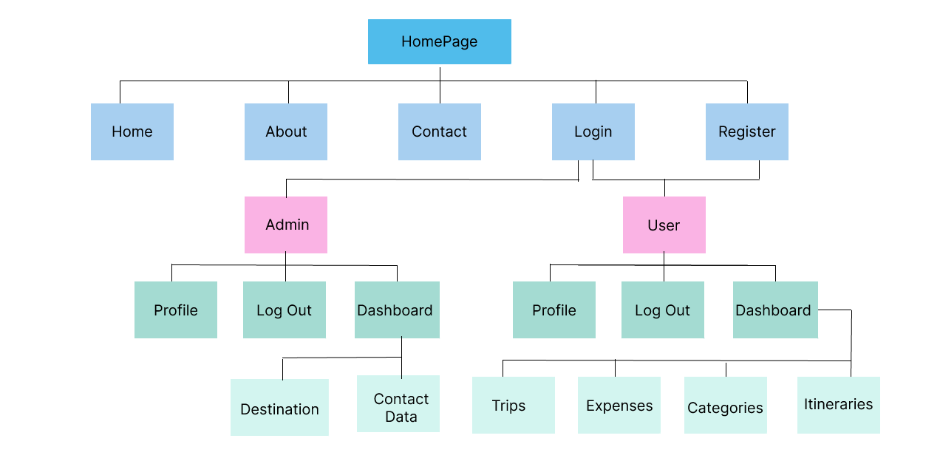

*7. Source code:*

*Navbar*

*This file is located in the folder of layouts with the name(website_header.blade.php) in which we have a navbar for all files in the website.* 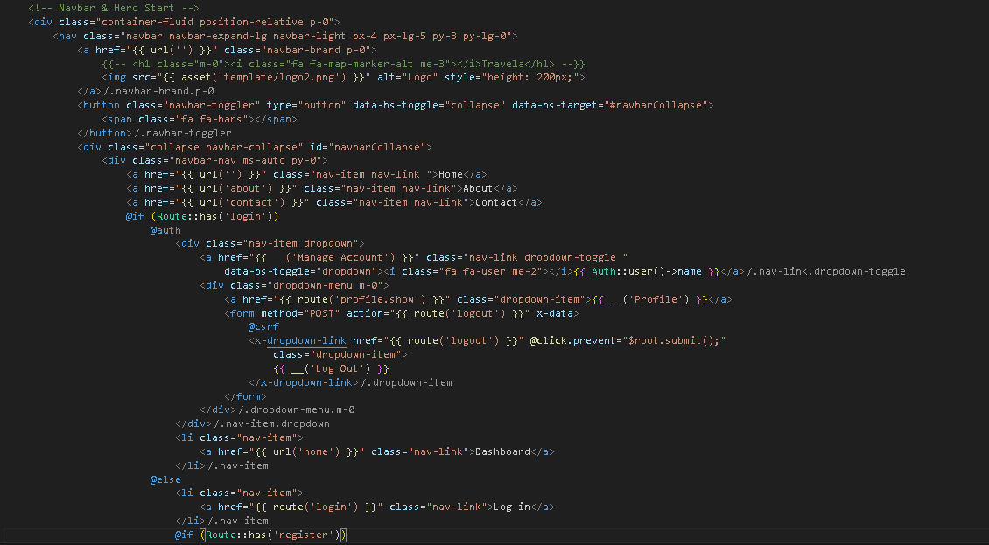

*Footer*

*This footer is also a part of (website_footer.blade.php) file.*

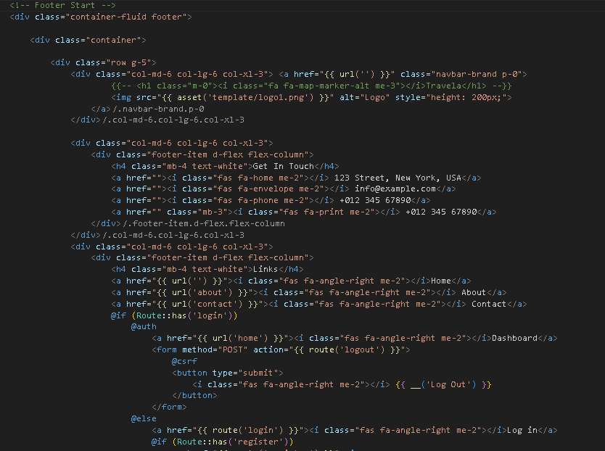

*Home Page*

*In this page user can see dynamic receptioinsts, stylists and also get acknowledge by new blogs which are coming from admin dashboard.*

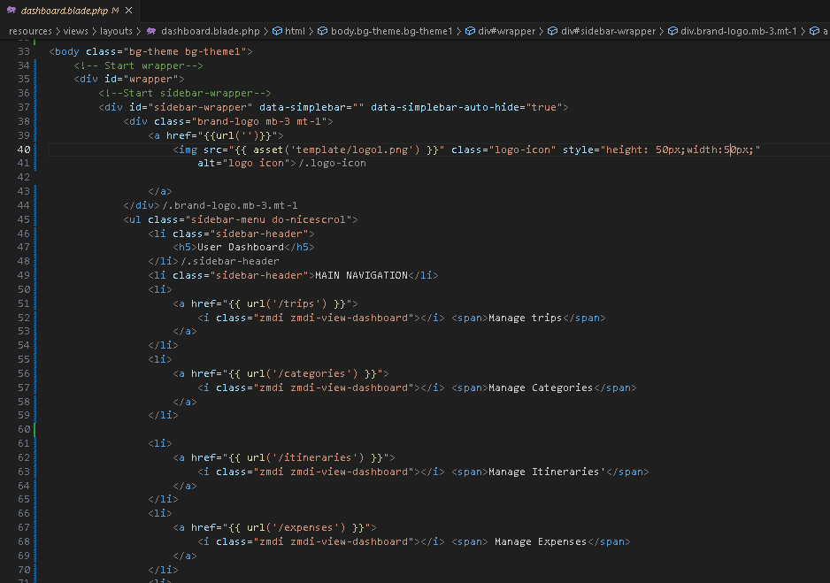

*Receptionists section in index.blade.php(home file).*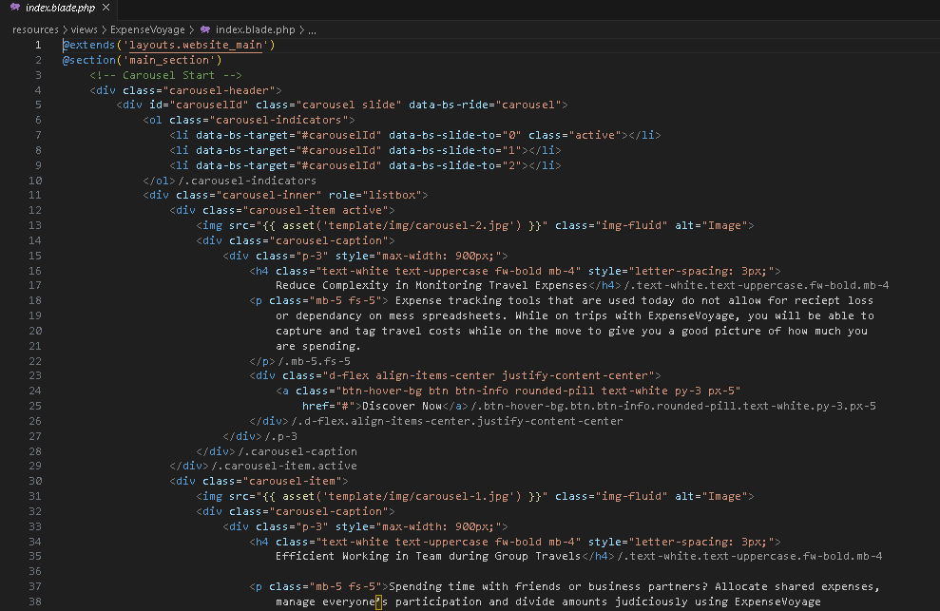

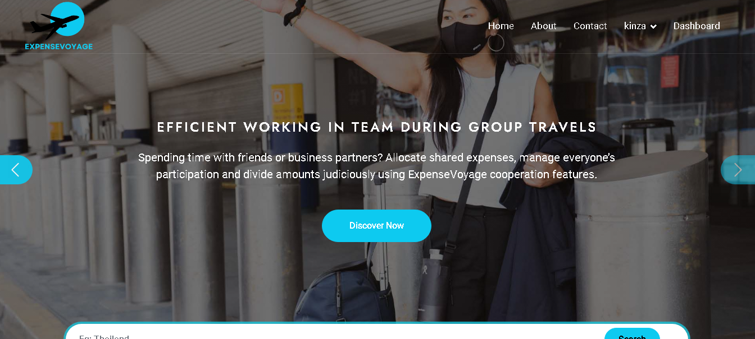

*About Page:*

*And this is about section for users on home file*

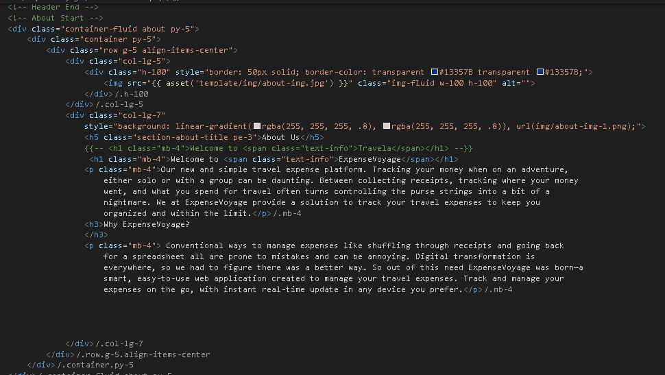

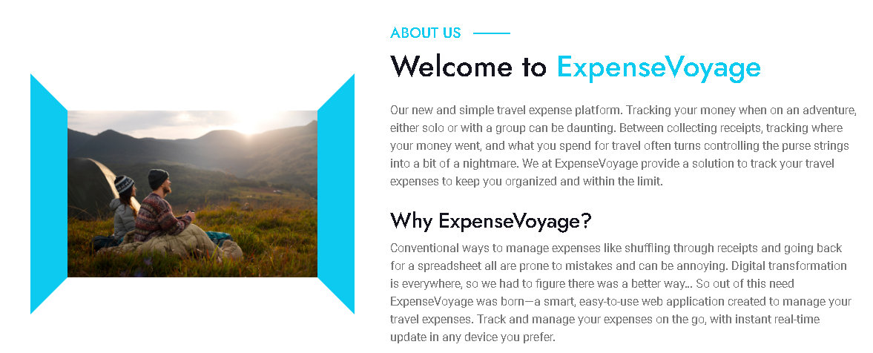

*Services Page:  
Here user can see the services provided by the admin in this website also can book appointment by clicking on the button.*

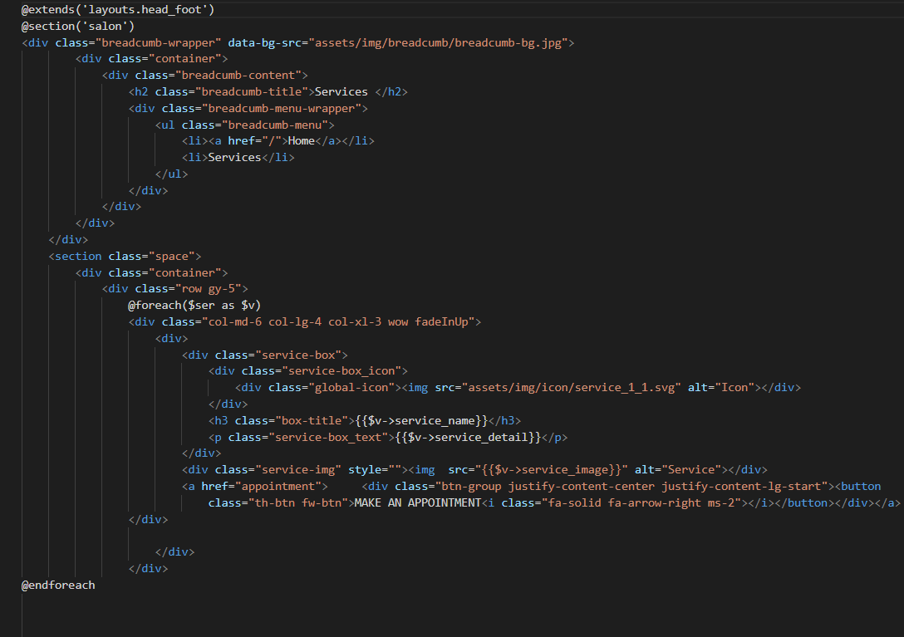

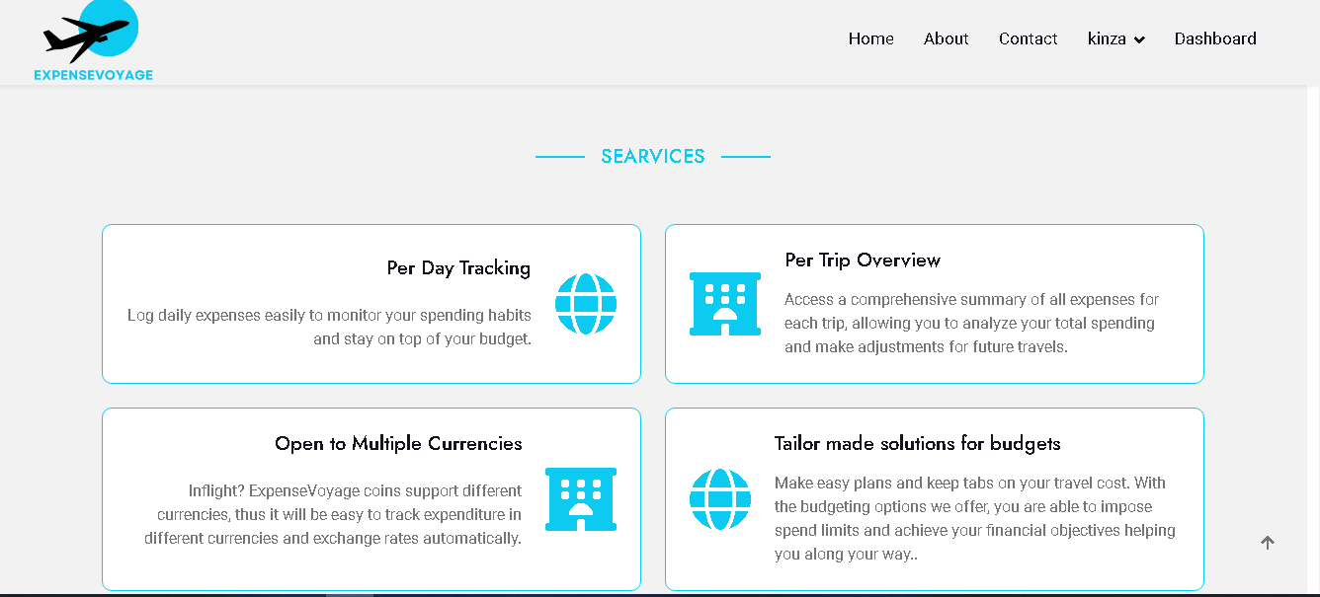

Contact File

Through this file user can easily communicate with us these fields are also validate so user must’ve to fill all the inputs.

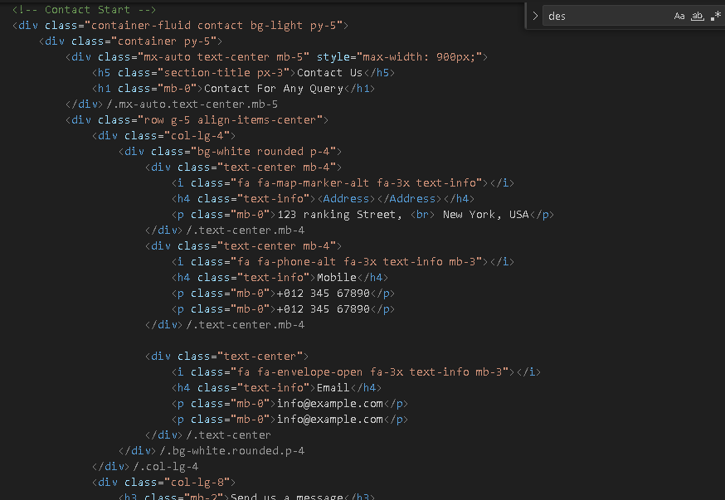

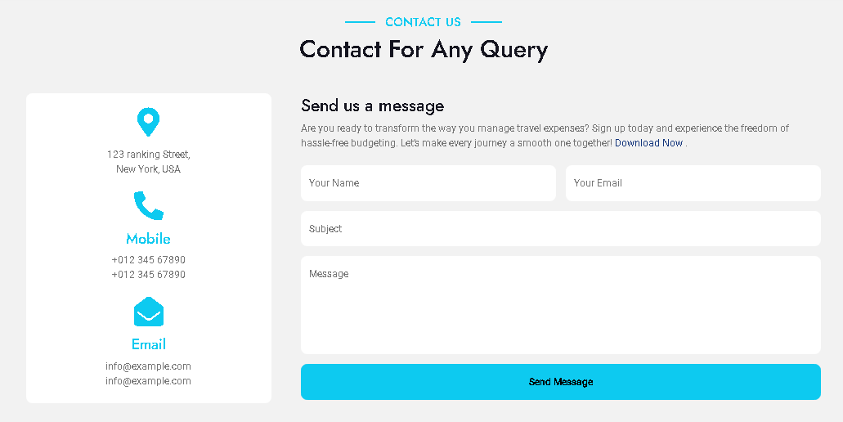

*There are 2 of dashboards:*

* ***Admin Dashboard****: in this admin can insert*
* *Destination on websites and manage user contact us data.*
* ***User Dashboard****: in this user can analyze their:*
* *Users must be able to create a new trip by specifying the destination, start date, and end date.*
* *Users must be able to edit and delete existing trips.*
* *Users must be able to view a list of all their trips.*
* *Itinerary Management*
* *Users must be able to add, edit, and delete itinerary items including flights, accommodations, and activities.*
* *Itinerary items must be categorizable (for example, transport, lodging, and activities).*
* *Users must be able to set an overall budget for each trip.*
* *The application must support multiple currencies [at least four, including US$, Euro €, GBP £, and your Local Currency] and provide exchange rates.*

*Admin Dashboard:*

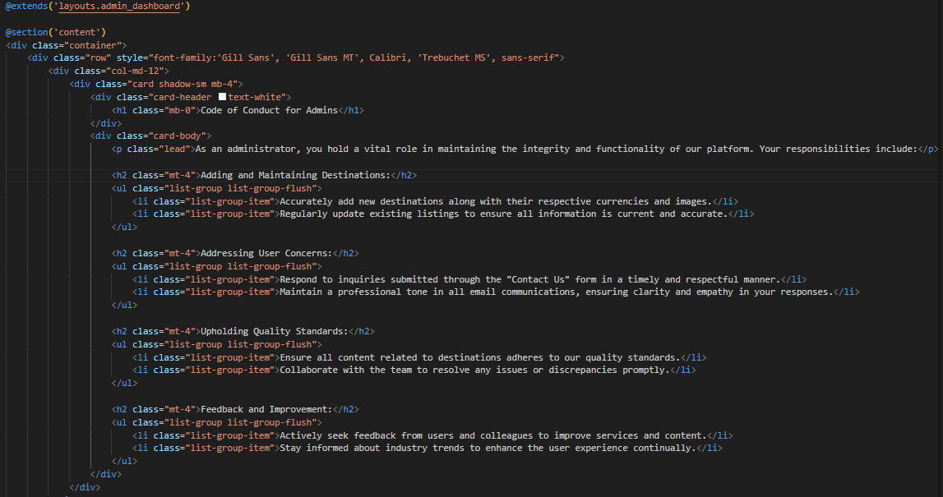

*User Dashboard*

*User create a new trip and edit and delete existing trips.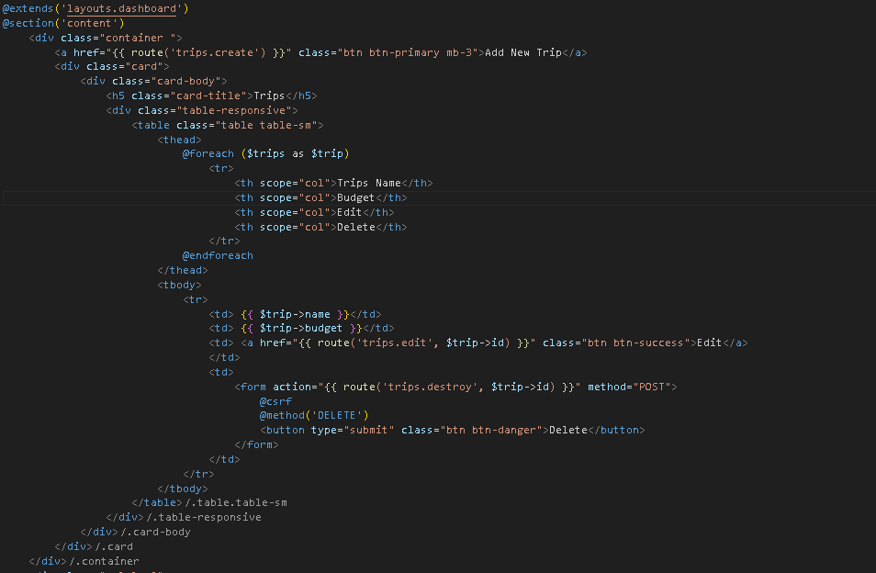*

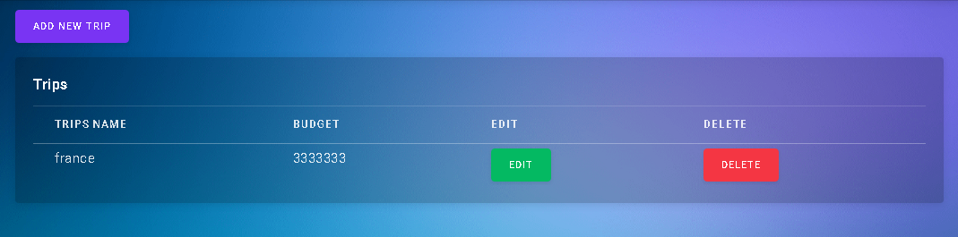

*Users must be able to add, edit, and delete, itinerary items must be categorizable (for example, transport, lodging, and activities).*

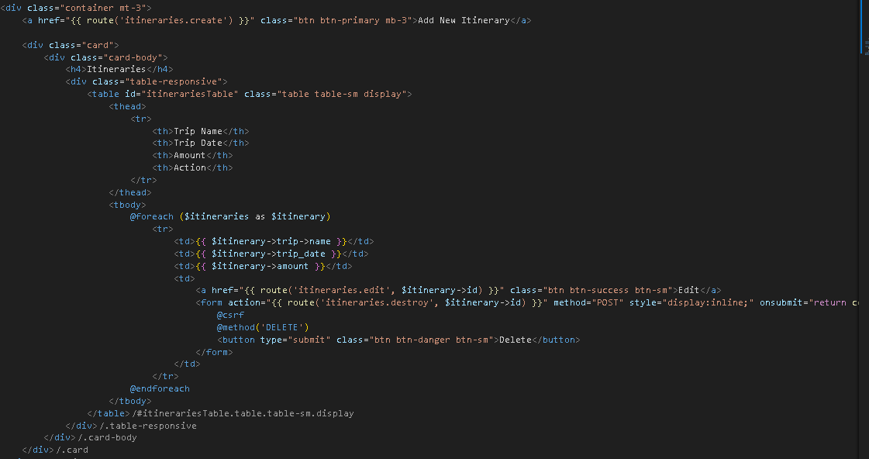

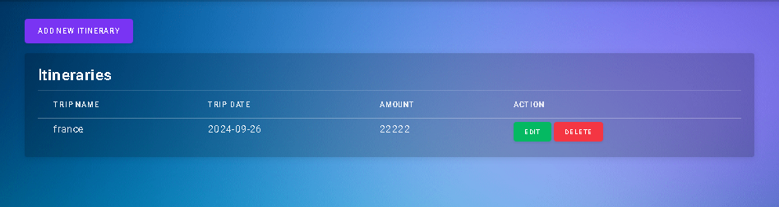

*• Users must be able to log expenses manually, specifying the amount, category, date, and notes.*

*• Users must be able to edit and delete logged expenses.*

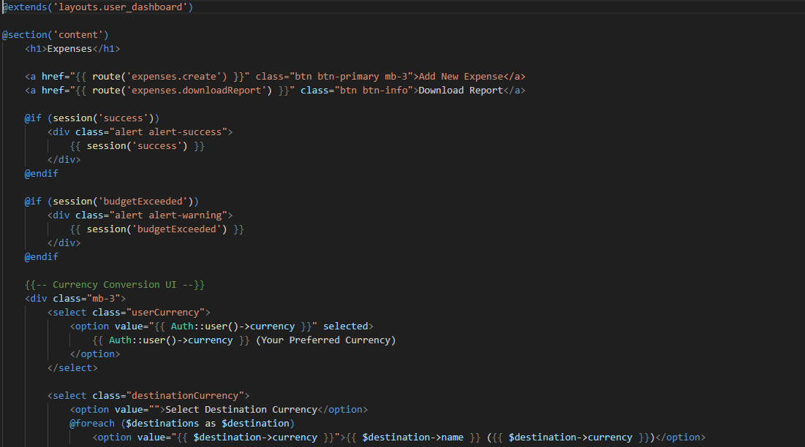

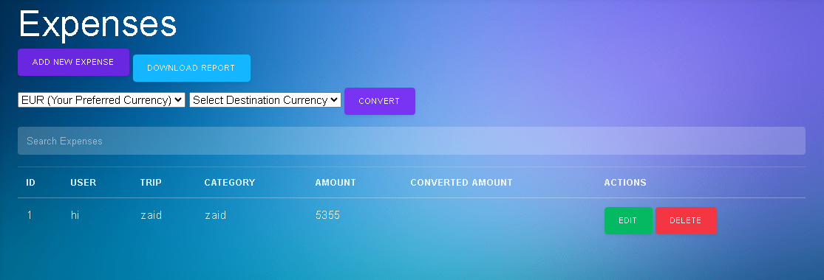

*Users must be able to set category-specific budgets.*

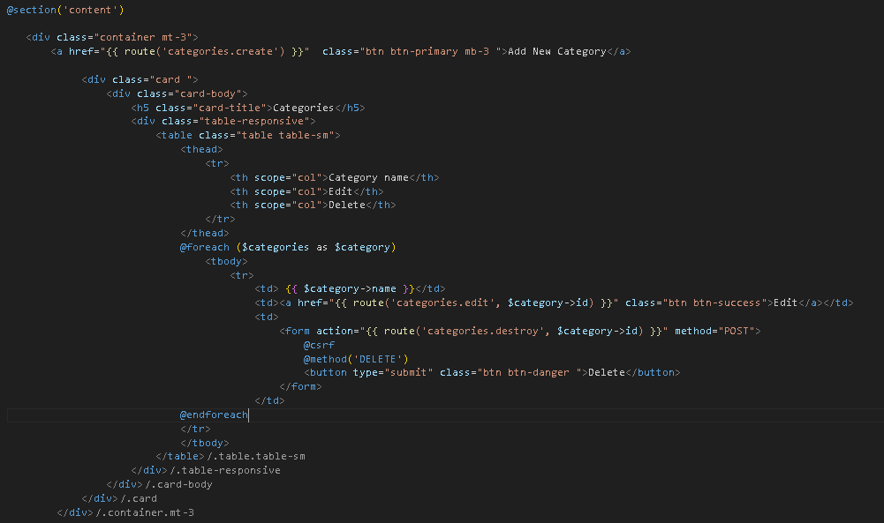

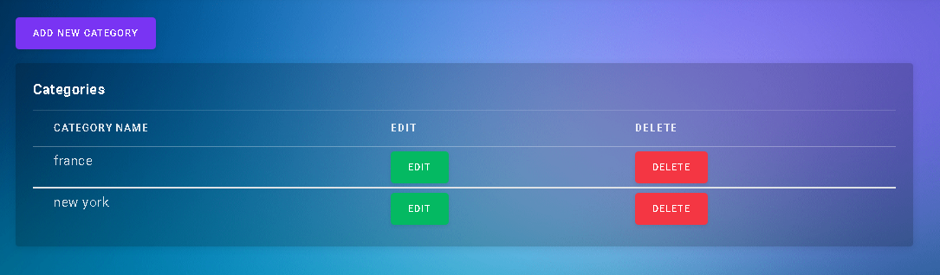

*There are 7 of Controllers:*

1. *Category Controller*

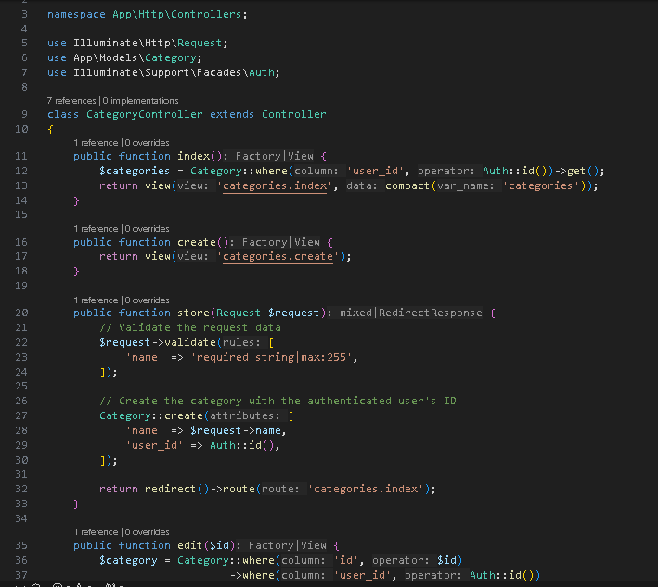

1. *ContactUsController*: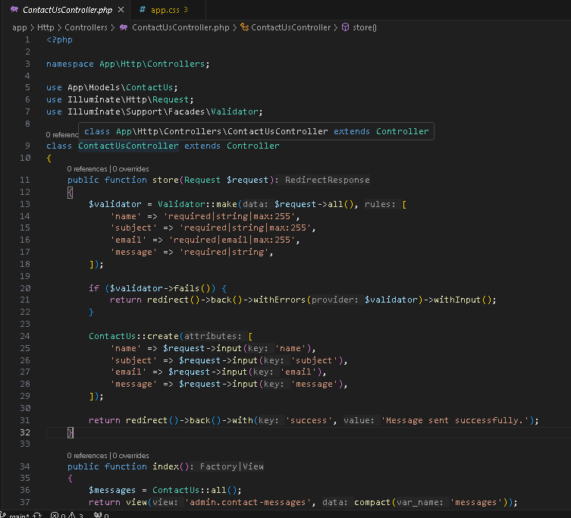
2. *Destination Controller: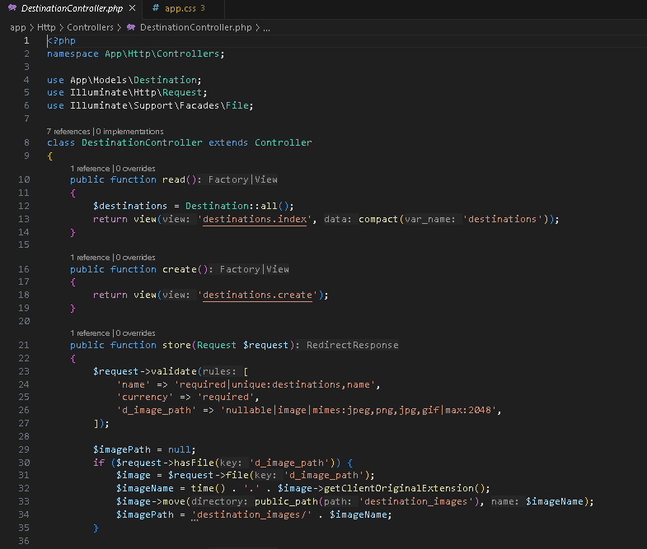*
3. *Expense Controller: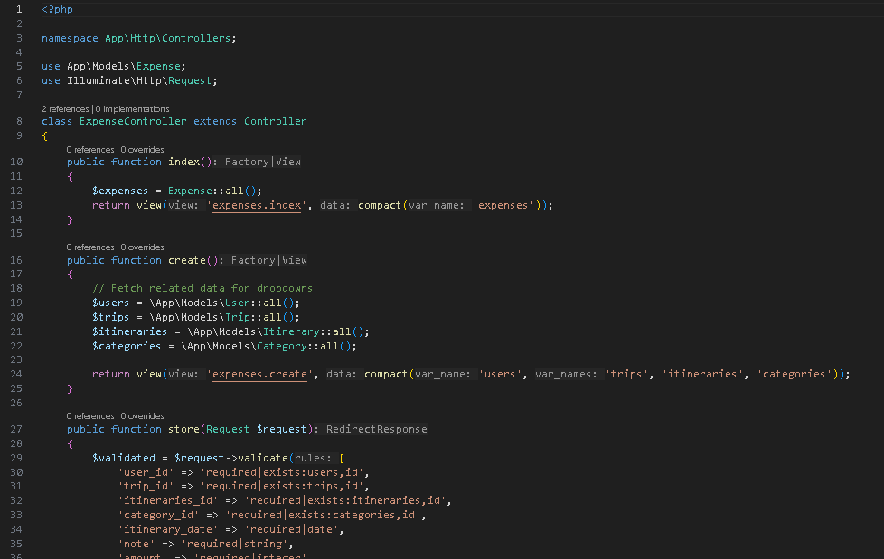*
4. *Home Controller: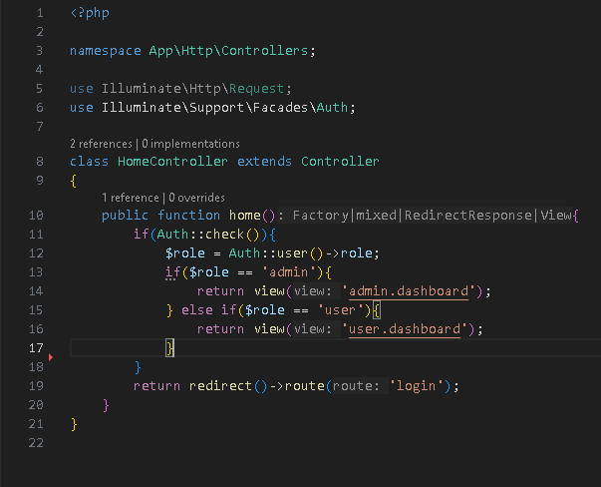*
5. *Itinerary Controller: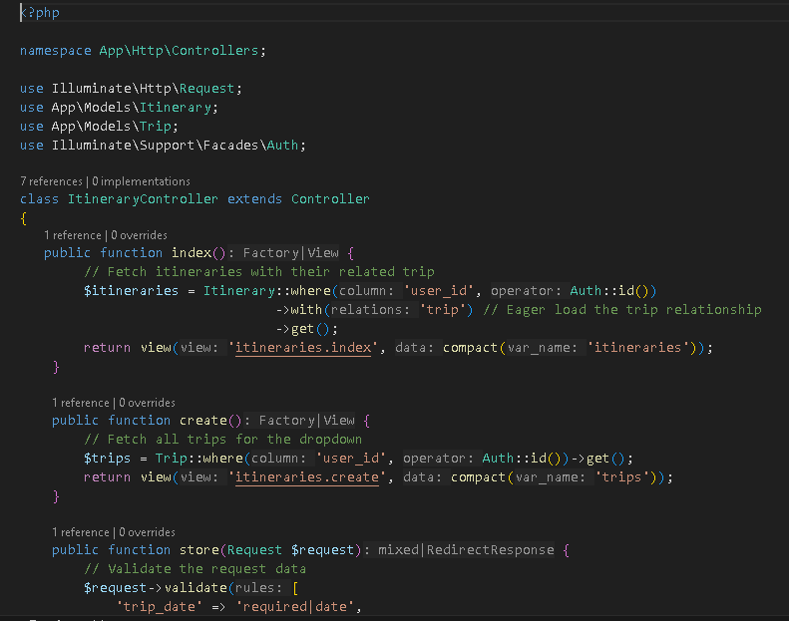*
6. *Trip Controller: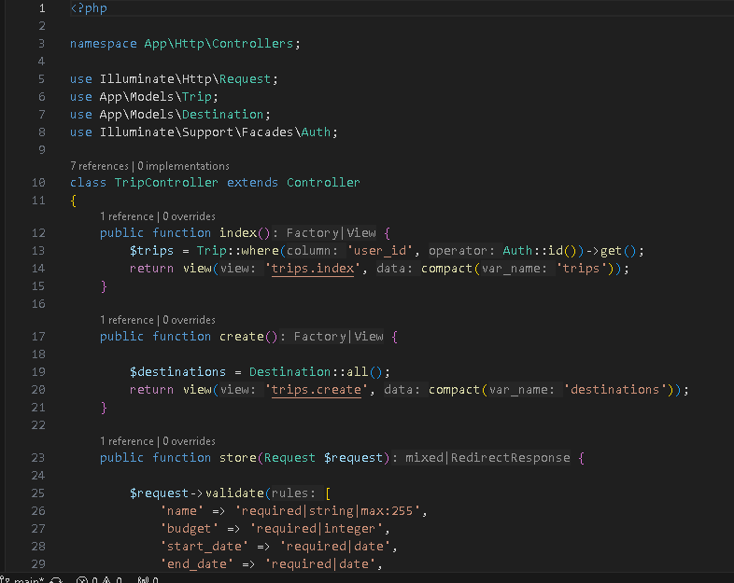*

*Routing (web.php):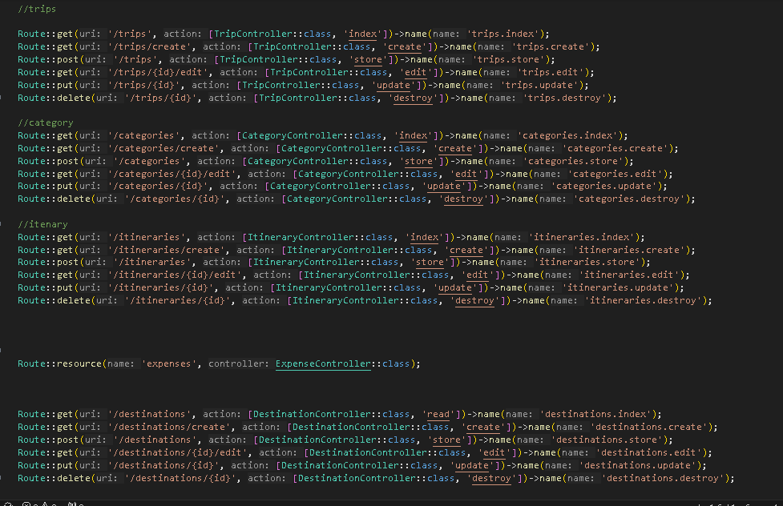*

*File’s Names:*

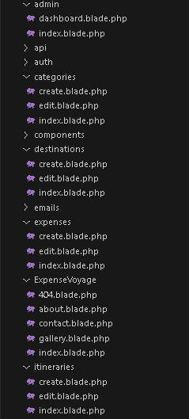 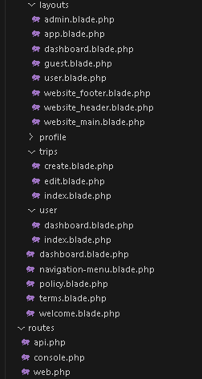

*Database Design:* 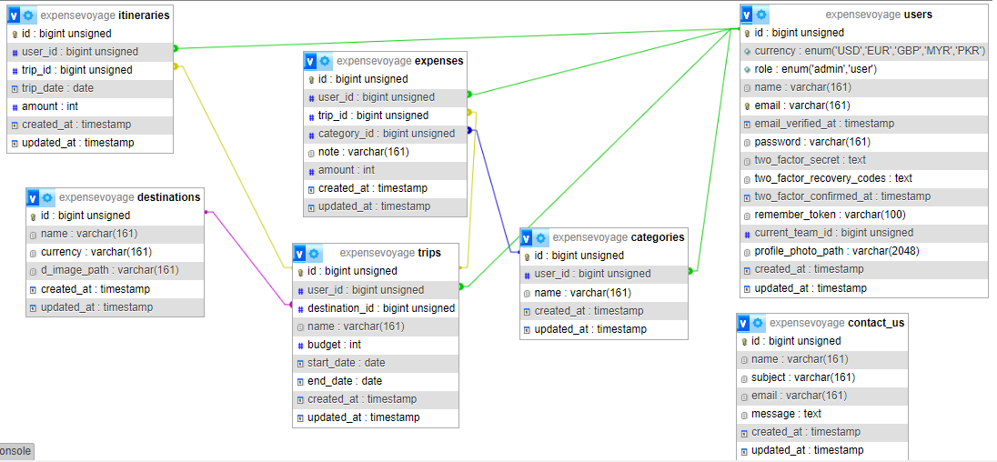

**Thank you, So Much for Reading Our Documentation,**